## 1.C Program to Check Whether a Number is Even or Odd

## 2.Program to Check Odd or Even Using Conditional Operator

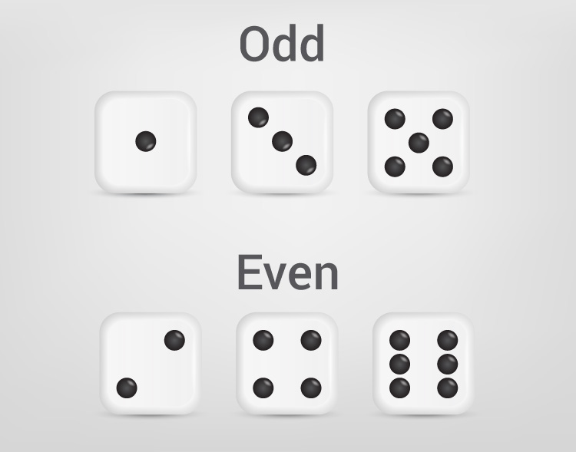

1 Program to Check Vowel or consonant (or operator) vc1

2 Program to Check Vowel or consonant (while loop) vc2

# Program to Find the Largest Number Among Three Numbers

1.Using only if ----------vc4

2.using only if...else---------------vc5

3. nested if...else------------------vc6

# Program to Generate Multiplication Table

Multiplication Table Up to 10 -----------vc7

Multiplication Table Up to a range (entered by the user) ---------vc8

# Program to Calculate the Sum of Natural Numbers

Sum of Natural Numbers Using for Loop ----------vc10

Sum of Natural Numbers Using while Loop-----------vc11

Program to Read Input Until User Enters a Positive Integer------vc12

## Factorial of a Number----vc13

## GCD Using for loop and if Statement—c14

## GCD Using while loop and if...else Statement---c15

## GCD for both positive and negative numbers-----c16

## LCM using while Loop and if Statement—c17

## LCM Calculation by Finding GCD-c18

# C Program to Reverse a Number----c19

# C Program to Check Whether a Number is Palindrome or Not---c20

# Program to Display Prime Numbers Between Two Intervals----c21

## Display Prime Numbers Between Two Intervals When Larger Number is Entered first----c22

## Check Armstrong Number of three digits---c23

## Check Armstrong Number of n digits---c24

# Programming Code To Create Pyramid and Pattern

### Program to print half pyramid using *---p1

*

* *

* * *

* * * *

* * * * *

### Program to print half pyramid a using numbers—p2

1

1 2

1 2 3

1 2 3 4

1 2 3 4 5

### Program to print half pyramid using alphabets—p3

A

B B

C C C

D D D D

E E E E E

### Inverted half pyramid using *--p4

* * * * *

* * * *

* * *

* *

*

### Inverted half pyramid using numbers----p5

1 2 3 4 5

1 2 3 4

1 2 3

1 2

1

### Program to print full pyramid using *----p6

*

* * *

* * * * *

* * * * * * *

* * * * * * * * *

### Program to print pyramid using numbers---p7

1

2 3 2

3 4 5 4 3

4 5 6 7 6 5 4

5 6 7 8 9 8 7 6 5

### Inverted full pyramid using *------p8

* * * * * * * * *

* * * * * * *

* * * * *

* * *

*

### Print Pascal's triangle---p9

1

1 1

1 2 1

1 3 3 1

1 4 6 4 1

1 5 10 10 5 1

### Print Floyd's Triangle.---p10

1

2 3

4 5 6

7 8 9 10